Writing Assessment-Dante, HO #4
Q: What were Dante’s Demons?

Step 1: Directions: Read the text, discuss and complete the graphic organizer with a partner.

The Divine Comedy, by Dante, Canto I (partial), The Vision of Hell

IN the midway of this our mortal life,
I found me in a gloomy wood, astray
Gone from the path direct: and e'en to tell
It were no easy task, how savage wild
That forest, how robust and rough its growth,
Which to remember only, my dismay
Renews, in bitterness not far from death.
Yet to discourse of what there good befell,
All else will I relate discover'd there.
How first I enter'd it I scarce can say,
Such sleepy dullness in that instant weigh'd
My senses down, when the true path I left,
But when a mountain's foot I reach'd, where clos'd
The valley, that had pierc'd my heart with dread,
I look'd aloft, and saw his shoulders broad
Already vested with that planet's beam,
Who leads all wanderers safe through every way.
Then was a little respite to the fear,
That in my heart's recesses deep had lain,
All of that night, so pitifully pass'd:
And as a man, with difficult short breath,
Forespent with toiling, 'scap'd from sea to shore,
Turns to the perilous wide waste, and stands
At gaze; e'en so my spirit, that yet fail'd
Struggling with terror, turn'd to view the straits,
That none hath pass'd and liv'd. My weary frame
After short pause recomforted, again
I journey'd on over that lonely steep,
The hinder foot still firmer. Scarce the ascent
Began, when, lo! a panther, nimble, light,
And cover'd with a speckled skin, appear'd,
Nor, when it saw me, vanish'd, rather strove
To check my onward going; that ofttimes
With purpose to retrace my steps I turn'd.
The hour was morning's prime, and on his way
Aloft the sun ascended with those stars,
That with him rose, when Love divine first mov'd
Those its fair works: so that with joyous hope
All things conspir'd to fill me, the gay skin
Of that swift animal, the matin dawn
And the sweet season. Soon that joy was chas'd,
And by new dread succeeded, when in view
A lion came, 'gainst me, as it appear'd,
With his head held aloft and hunger-mad,
That e'en the air was fear-struck. A she-wolf
Was at his heels, who in her leanness seem'd
Full of all wants, and many a land hath made
Disconsolate ere now. She with such fear
O'erwhelmed me, at the sight of her appall'd,
That of the height all hope I lost. As one,
Who with his gain elated, sees the time
When all unwares is gone, he inwardly
Mourns with heart-griping anguish; such was I,
Haunted by that fell beast, never at peace,
Who coming o'er against me, by degrees
Impell'd me where the sun in silence rests.
While to the lower space with backward step
I fell, my ken discern'd the form one of one,
Whose voice seem'd faint through long disuse of speech.
When him in that great desert I espied,
"Have mercy on me!" cried I out aloud,
"Spirit! or living man! what e'er thou be!"
He answer'd: "Now not man, man once I was,
And born of Lombard parents, Mantuana both
By country, when the power of Julius yet
Was scarcely firm. At Rome my life was past
Beneath the mild Augustus, in the time
Of fabled deities and false. A bard
Was I, and made Anchises' upright son
The subject of my song, who came from Troy,
When the flames prey'd on Ilium's haughty towers.
But thou, say wherefore to such perils past
Return'st thou? wherefore not this pleasant mount
Ascendest, cause and source of all delight?"
"And art thou then that Virgil, that well-spring,
From which such copious floods of eloquence
Have issued?" I with front abash'd replied.
"Glory and light of all the tuneful train!
May it avail me that I long with zeal
Have sought thy volume, and with love immense
Have conn'd it o'er. My master thou and guide!
Thou he from whom alone I have deriv'd
That style, which for its beauty into fame
Exalts me. See the beast, from whom I fled.
O save me from her, thou illustrious sage!

This excerpt from the eBook is for the use of anyone anywhere at no cost and with almost no restrictions whatsoever. You may copy it, give it away or re-use it under the terms of the Project Gutenberg License included with this eBook or online at www.gutenberg.net

Step 2: Directions: Prepare for a discussion of the following questions. Be prepared to cite evidence from the text to support your answers during the discussion.

- What encounters does Dante experience and what do they represent?

- What does the allusion to the dark forest represent? Are there others?

- What are some significant verses?

Step 3: Planned Writing
Directions: Reread the text, review your notes and responses to the last task.
You have partially read one of “Danteworlds”- Hell. He faces his midlife crisis in this book.
What problems or issues can you associate with such an experience? Or similar issues that represent a change in life? Is it Hell, Purgatory or Paradise?

Step 4: Write an essay that explains your reaction to Dante’s Divine Comedy. Support your explanation with evidence from the text and your own personal experience.
Your response will be scored using the following rubric. Peer editing will be used.

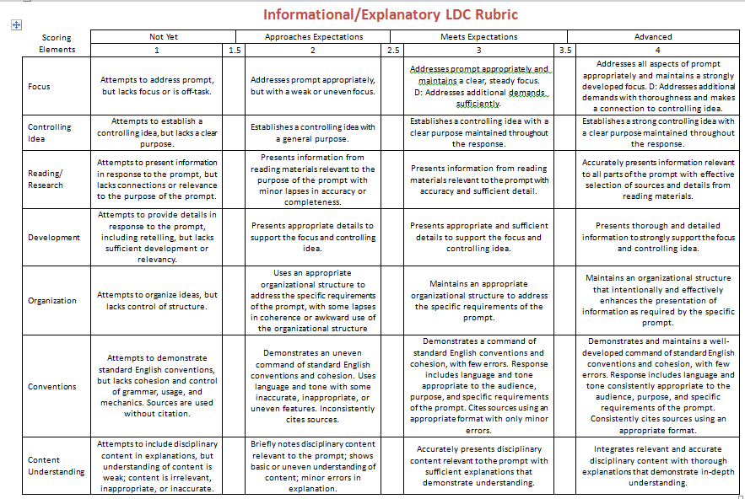

Ensemble Learning, 2017

